**Final Year Project idea**

A game that has mental health/disability incorporated within it, about representation and helping, also including stuff about accessibility and make it easier for people with disabilities to play the game, for example including colour blindness settings, ability to change controls on keyboard to best suit a person or a specific controller and set up key bindings and controller settings so it makes it more accessible for people with a physical disability.

Some first idea scribbles

-gaming and mental health

-create a game about mental health or that helps it

-on the report discuss how games affect mental health and the cons and pros of games and how effective representation of mental health in games is for people and if the representation is accurate or appropriate.

-gaming and accessibility/disabilities

-making games accessible and how disabilities are portrayed in games

-colour blind accessibility

-physical disability, making a controller or program, or able to program buttons/controllers to fit persons needs

-game called inside – mental health – bo burnham inspiration, game about being trapped indoors because of lockdown or other reason and going through each day.

Research

-mental health

-different disabilities

-how people make games accessible

-different controllers

-key binding

-general code research

-existing games that are similar

Plan for now (14/10/21)

-read up on books about disabilities, mental health, gaming and disabilities and accessibility and gather a bunch of research for report purposes and to also help in designing game – buy books, read articles, search google scholar.

-plan and design game, what type of game – genre and play style, any characters, world design, how long of a game, a simple game or long, art style of game.

-work out what the title of the project will be

-figure out if mostly focusing on game or the settings and making it accessible side of things (or if doing both)

-what disabilities to be included

-colour blind – add colour blind settings for the three different types

-motor function impairment – changing controller buttons, able to use specific controllers or change keyboard bindings

-deaf – add subtitles for things that call for it

-legally blind – audio play for every mouse/joy-con interaction

-what platform I am going to use, c++ visual studio, unity, or something else

Research I have found so far:

Amazon music podcast – accessibility in gaming by chelby farley

Book - Game Usability: advancing the player experience by Katherine Isbister

Book – Accessibility in games: Including people with disabilities by Silvio Carrera

Book – Approachable Accessibility: Planning for success by Martine Dowden

Meeting (15/10/21)

Jethro suggested to make Gantt chart for project management and progress

Need to get ethic, global and project contracts done before the 5th November 2021 at 12pm

Project idea – controls of different genres, make it easier, get settings that have been mapped from a different game and move the settings.

Engine -> c++ - platformer, scrolling, reflexes, inputs

Could include some Fuzzy Logic

-Capture mapping of controllers/keyboards, how these mappings can move from genre to genre, how these benefits disabled players and makes games more accessible and easier to play for them.

Prototype games – small games, capture mapping, different genres, get people to play test (could be difficult to test)

Testing will be difficult to find disabled players that will be able to test it out fully

Research on what representation I want and what there already is, what people out there even want and are looking for

Contacting people from the community to get feedback from them, could try special effect charity, or the podcast on amazon music by Chelby Farley (a person who is legally blind)

Objectives – things to be marked against – need to be clear

* Unity, c++ -> reuse
* Ability to map controls and capture that mapping
* How many games and levels to do?
* Test from individuals to understand this
* Gantt chart and update as I go along

Feeling more confident making games in unity for prototypes, could use c++ for main program for mapping – need to look into fuzzy and how that will relate and can be used.

Need to research the representation of disability not just accessibility.

Report

* Needs to be 8,000 words maximum with no 10% + threshold, from first chapter to last chapter, does not include title page, acknowledgement, abstract, table of contents, list of figures, list of tables, reference list and appendices.
* Keep appendices short, informative, and relevant.
* Other documents can be linked and put in one drive folder, documents such as questionnaires, test cases, etc. Needs to be shared with supervisor and cite accordingly in report.
* Harvard referencing must be used

Intro idea – two big problems in the games industry is disabled representation within games whether it be physical or mental disabilities, including mental health, and the other issue is, the accessibility within games. And the aim of this project is to explore and tackle these issues.

Title idea – To create a mapping methodology for game accessibility and representation.

Creating a mapping program and game prototypes for game accessibility and representation.

Creating a mapping program for game accessibility.

*Lecture 25/10/21*

Title – three things to draw out from the title, example: an investigation into the risks of using drone technology for commercial purposes

Think about scope:

-timescale: current or historic

-countries: UK or international

-discipline: perspective

-specific groups or types: gender, age, purpose, size

Using a research plan:

Key element of question Alternative terminology

Drone tech unmanned aircraft or aerial vehicles, uavs, tricopter

Commercial purposes commerce, business, enterprise, surveillance, delivery services

Risks pitfalls, disadvantages

Choose keywords carefully

* Singulars, plurals, phrases
* How terms are combined
* Alternative terminology, synonyms, and variation in language
* **Major influence on search effectiveness – be precise and systematic**

Formulate your search query

* Use “ “ to search for phrases
* Use * at the end of a word to search for all possible endings, e.g. comput* will search for computing, computer, computers, etc…
* “drone technology” AND commerce
* “commercial drone” AND (risk OR disadvantage)
* (UAV OR drone) AND commerc* AND risk*

Inter Library loans – if we do not have the book or journal article you need in our collections, it may be possible to request it via the free inter library loan service – apply online from the library website: library.dmu.ac.uk/illguide

Summary:

* Plan and revise your search strategy to ensure you are searching effectively
* Use library search and the specialist computing databases to find academic sources
* Make sure you evaluate the sources you find in terms of their relevance and reliability

Back up particular approach to project with sources and research – report is in third person

Gathering primary data will be later in report, appendices and stuff, literature review is more research and secondary data.

Primary data results will come into review and methodology

Meeting 3/11/21

Notes:

* First game to be 2D simple bo burnham style game, a puzzle game with not a massive number of controls to be needed, simple.
* Second game to be a 3D game so can see transfer of control mapping between 2D and 3D, also will have a disabled protagonist, designed from a mixture of things researched and what would be best represented. Genre to be decided.
* Will control mapping be both ways or just one way?

Meeting 24/11/21

* Test plan
* Split things down and moving things across
* Things for first deliverable

Colour-blind ideas:

Battlefield 4 colour-blind settings - <https://imgur.com/gallery/iBRGY#kOmonaA>

Simulate colour-blindness - <https://paletton.com/#uid=1000u0kllllaFw0g0qFqFg0w0aF>

See how colour-blind settings can be mapped and transferred between prototype game as well and see if it works or helps, would work with filters but maybe not if using shaders, but could try and work it out.

Try using more symbols and text than rely solely on colour.

Since the 1950s video games have grown massively in the games market and in technological advances. The number of people playing video games has also risen massively over the years, and with more players come more different types of players and player styles. Back in the early days of video games, controls were very simple with only a couple of buttons, or a joystick needed to play them, however with the advancement of hardware and technology over the years, controllers have become more complex with multiple buttons and keypads or joy sticks on just one controller. This makes it a lot more difficult for those with motor disabilities to enjoy or be able to play modern video games.

Prototype 1 is a wheelchair basketball game, it will be a simple 2D basketball shooter, where you must aim for the basketball hoop and gain points as you score, where the main character you control is a wheelchair basketball player, and you move up and down to aim towards the hoop and have lines to see where you are throwing the ball. The levels will get harder with different hoop positions and later moving hoops, can have different difficulty levels possibly, using my fuzzy logic system to output recommended game difficulty. Will have an arrow meter that goes up and down and the player will have to press the button to launch the basketball, and the higher the meter the more power the throw will have, the very easy option can be to not have this meter and just aim and throw the ball, but for players who want more of a challenge can have this meter. Can have obstacles and stuff as levels go on, only going to have like 4 or 5 levels for each thing.

Even though it is a simple idea for a game and something that would be more suitable for mobile devices, mobile games aren’t always the most accessible, so this can be a small fun game for someone who just wants a chill and simple game which is not usually as accessible for them. Plus, there are plenty of games on steam that could be mobile or PC and it’s fine to have a game across multiple platforms, just think of this as the PC version.

Prototype 2 simple 3d shooter where main character has some mental disability or illness, 3d game can help showcase map control program working between 2d and 3d games. 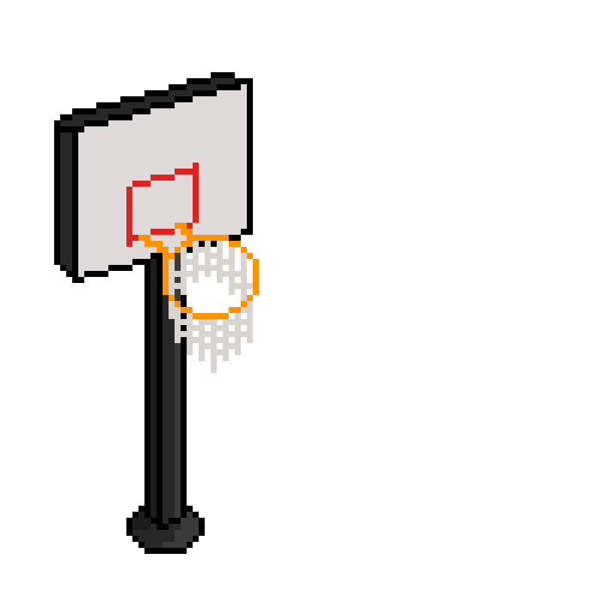

<https://docs.unity3d.com/ScriptReference/CharacterController.Move.html>

<https://www.youtube.com/watch?v=0y-NeTs5c4A&list=PLQq25VykDHnsbYUvE_0OniZKV_yhmVKIg&index=3&ab_channel=Masteryst>

Game Usability: advancing the player experience by Katherine Isbister and Noah Schaffer is a book that I first had on my mind when starting this project, my first thought was that usability and accessibility were one in the same, however this was not the case. Usability is about making software usable by paying attention to human limits in memory, perception, and attention ‌Isbister, (K. and Schaffer, N. (2008), pg. 4). As Silvio Carrera rightly says, accessibility “must not be confused with usability which is to what extent can a product be used by a specific user in order to attain a specific goal” (Carrera, S. (2016), pg. 13) But this book still gave me some insight into controllers and other UI interfaces within video games which can still be applied in this project towards the creation of the two prototype games. …(continue)